November 2024
Department Run Analysis
- Fire – 8
- Medical – 50
- MVA’s – 4
- Service Calls – 3
- Canceled – 0
- Mutual Aid – 9
Total Incidents for November 2024 - 74

Mutual Aid Analysis
Mutual Aid Received –
District –
- Defuniak Springs – 1 (Fire)

Mutual Aid Given -
District -
- FR11 (Mossy Head) – 3 (Fires)
- FR12 (Freeport) – 2 (Cancelled)
- FR02 (Darlington) – 2 (Canceled)
- Defuniak Springs – 2 (Fire )

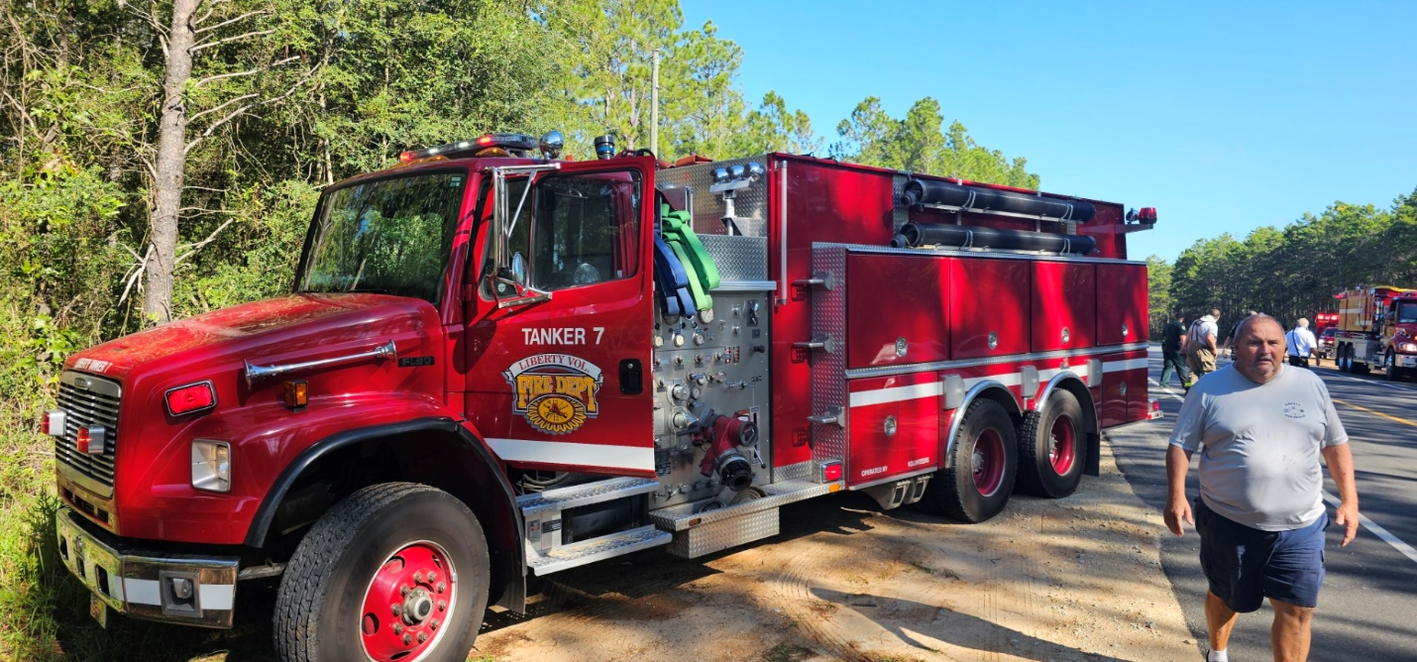
November 2024 Monthly Runs
Total Calls
- Fire – 8
- Medical – 50
- MVA’s – 4
- Service Calls – 3
- Canceled – 0
- Mutual Aid – 9

